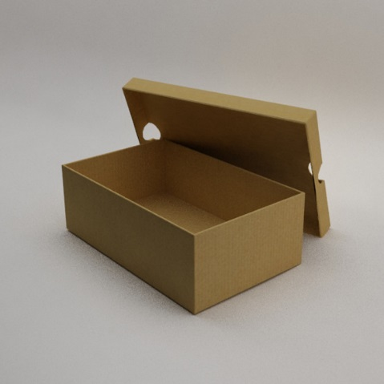
Name ______________________ Class _____
TITLE: Silencing Sound

PROBLEM: Design a SOUNDPROOF BOX to block the annoying sound of a ticking watch (or metronome)

HYPOTHESIS: I put ______________________________________ in my box because _____________________________________________________
____________________________________________________________________________________________________________________________________________________________________________________
PROCEDURE:
- Design and make modifications to box no larger than a shoe box (no boot boxes!). Box must allow for installing a ticking metronome (app on teacher’s iPhone)
- Bring your soundproof box back to class
- Test box according to the following method
  - Listen quietly for 20 seconds to hear room noises
  - Listen quietly for 20 seconds to hear for metronome
  - Install metronome (iPhone) in box and close box
0 No sound = no card
1 Slight sound = show side 1
2 Sound = show side 2
Total cards after 5 seconds in box
RECORD DATA: Use data table to list materials used in box
Materials | Audience Score
Your Box
Most Soundproof entry (Quietest); if yours is best, use data from ‘least quiet’ entry
CONCLUSION: Analyze the results (of yours vs. most soundproof entry) and explain the success of them in muffling sound. Give your best scientific reasoning.

Looking at the two entries (yours vs. winner—if not bad, what did you learn about absorbing, reflecting, mediums, and materials?

What materials soundproof the most? The least? Explain why you think this happens.

Do you trust these results? Why or why not?
(hint: what could possibly be wrong with how this experiment went?)

What would you change (in design) if you could do the experiment again?

