Name ________________ Class ___ Date ________
Calculating Wave Energy

Objectives | You will be able to investigate different ways in which waves carry energy. As a result of data collection and analysis, you should be able to explain the relationship between energy and wave size (amplitude). You should also be able to relate wave energy to generation of power for human activities
Guiding Questions | How much energy is in a wave?  How is the amount of energy in a wave related to the wave’s size?

Procedure

Part I. Measuring Real Waves
- If you are using a computer, you will need to access the NOAA National Buoy Data Center at: Web Link - NOAA Buoy Data (http://www.ndbc.noaa.gov/).

Buoy Data
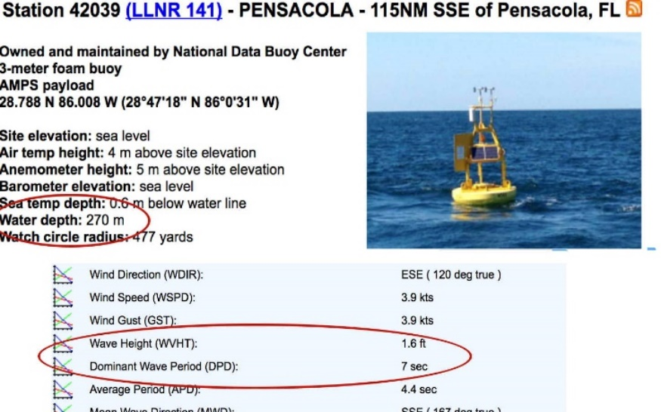
Buoy Data
- Complete the data table (next page), finding data for a total of 10 different buoys*. Try to find buoys in different parts of the ocean and with different wave sizes.
* Don’t forget to check the North Shore of Hawai’i, where the surfers sometimes find monster waves!
Once you’ve chosen the buoys, compare them and consider: Where did you find the waves that produced the most energy? The least energy?

DATA TABLE NAME ____________ Class__
(use NOAA Buoy Data, (http://www.ndbc.noaa.gov/)
1  1Buoy ID  and  Location | 2  Water Depth (meters): | 3  Significant Wave Height (feet): | 4  Wave Period (seconds) |  | 5  Question 3:  Wave Energy kW/m | 6  kW energy produced over time (kW/m Period)

Example:

44258 – Halifax Canada

- Once you have collected data for ten different waves, enter the information you collected from the NOAA buoys into the Wave Energy Calculator Web App by clicking on the Supporting Material - Wave Energy Calculator (on the Jason website: https://gated2.jason.org/ResourceDetails/29351/SupportingMaterial The wave energy calculator will provide information about the amount of energy in each wave in kilowatts per meter (kW/m).
RECORD YOUR ANSWERS in Column 5

- Now that you have calculated the amount of energy produced per meter of wave, let’s find out what features of the wave determine how much energy it can produce.

Take the data for one of your waves. Double the wave height (from column 3) so that waves that are coming in are twice as high. Use the wave energy calculator to find the answer. How does this affect the amount of energy produced? Show the output for both waves below.

Buoy | Original Wave’s height | Original Wave’s calculated kW/m | Multiply: 2 X (Column 3) | Calculated  Output if wave height were doubled

- Complete the calculations for the remaining nine waves and record your answer in column 6 of the Data Table. Analyze the results showing the difference in energy production (col 5 vs. col 6) listed for each wave. What is the relationship between wave height and energy produced?

- Take the data for one wave. Double the wave period (from Column 4, multiply by 2) so that waves are coming in slower. How does this impact the energy output? Show the output for both waves below.
Original Wave “Slower” Wave
Energy
Produced:
From this information, a slower wave frequency… _________________________________
___________________________________________________________________________________

44258, 52202, 44100, 64045, 46219, 46214, 46131, 46061, 46081, 4603

