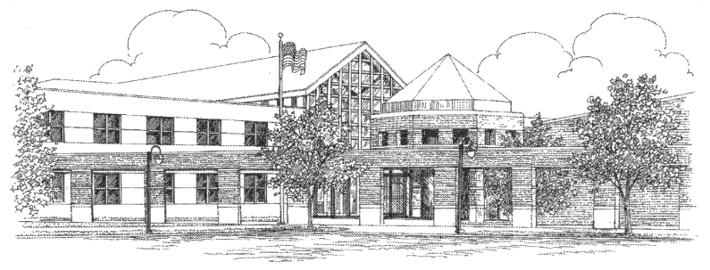

EAST LYME HIGH SCHOOL

Michael Susi, Principal
Jeffrey Provost, Assistant Principal
Laurie M. Zaneski, Assistant Principal
Dr. Michael Sullivan, Assistant Principal

30 Chesterfield Road • P.O. Box 210
East Lyme, Connecticut 06333-0210
Telephone: (860) 739-6946
Facsimile: (860) 739-1241

Dance Permission Slip

_______________________ has my permission to attend the Winter Ball on Saturday, Jan. 31st from 7-10 p.m. There are rules for Social Events at the High School. I am aware of the dance rules of conduct beginning on Page 38 of the student handbook. Additionally, students arriving 1 ½ hour after the start of the dance will not be permitted entrance without prior approval from the school administration. Students who leave prior to the end of the dance will not be allowed re-entry into the dance and are considered to have left with the parental permission. School staff will not contact parents of students who leave a school dance early.

Dance/Prom Expectations:

Related to our school’s social expectations, we have had excellent participation in our dances and proms at East Lyme High School in the past and we expect that that will continue in the future. However, like many high schools in the area and around the state we have seen an increase in inappropriate dancing in the last several years. After gaining input from surrounding schools and input from our students and parents we have developed a protocol to respond to inappropriate dancing at our functions. At the discretion of the administration, students who are deemed to be dancing inappropriately will have their parents contacted and be removed from the dance. Students who are removed from the dance or prom for inappropriate dance risk the possibility that they may not participate in upcoming events as well.

Students will receive a verbal warning BUT if the behavior continues they will be removed from the dance.

____________________________
Student Signature/Date

____________________________
Parent Signature/ Date

____________________________
Phone number(s) to be reached if necessary

