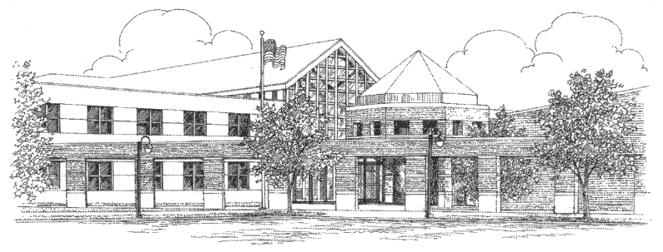

EAST LYME HIGH SCHOOL

Michael Susi, Principal
Jeffrey Provost, Assistant Principal
Laurie M. Zaneski, Assistant Principal
Dr. Michael Sullivan, Assistant Principal

30 Chesterfield Road • P.O. Box 210
East Lyme, Connecticut 06333-0210
Telephone: (860) 739-6946
Facsimile: (860) 739-1241

February 2014

Dear Parents/Guardians of All Students:

As of 2014 the Connecticut Department of Education has instituted a change in state-wide testing. CAPT
(Connecticut Academic Performance Test) will still assess sophomores, but only in the science discipline, as we move toward a new generation of testing known as SBAC (Smarter Balance Assessment Consortium). SBAC, a computer-based assessment, will offer a more interactive experience to students in their junior year. Each testing day will have testing in the morning and an abbreviated four-block schedule after lunch.

The CAPT will be administered on Tuesday, March 11, 2014. All sophomores are required by law to take these tests. Juniors who did not receive a passing score on the Science CAPT are also required to take a re-test. Please be advised that passing CAPT is still a graduation requirement. SBAC, also a state requirement by law, will be administered on March 27th, as well as on April 1st, 3rd, and 8th. Both tests contain make-up dates in case of student/family emergencies or illness; however, all students are expected to make every effort to attend their testing days. Furthermore, it is imperative that all testing students arrive to school on time as tests will begin promptly at 7:45. Because these are high-stake tests, and students will be testing in classrooms throughout the building, all students not taking tests will not be permitted in the high school.

It is important to remind everyone that on all testing dates regular classes will be in session after the lunch break. All students who do not take tests are required to be in school during regular classes. We will use the “Late Bus Route” to provide transportation to students who need it. Transportation will have two bus pick-ups. The morning pick-up during SBAC will be a consolidated route for any juniors needing transportation to school. The afternoon pick-up will be a full bus route and will pick up ALL students at their regular bus stops. Juniors from East Lyme and Salem needing bus pick-up during SBAC are asked to sign up in the Main Office by the end of the school day, Friday, March 28th. Salem students must be at Salem School by 7:15 for pick-up.

The CAPT testing day will consist of two bus runs: an abbreviated run in the morning for sophomores and a full bus run in the afternoon for all other students needing transportation to school. Juniors taking a re-test and sophomores in East Lyme and Salem needing a bus pick-up during the CAPT testing are asked to sign up in the Main Office by Friday, March 3rd. Salem students must be at Salem School by 7:15 for pick-up. For East Lyme students, pick-up times and locations will be posted next week.

For your convenience, a full testing schedule is included on the back of this letter. Should you have any questions regarding these important tests, please do not hesitate to contact Mr. Jeff Handler, CAPT/SBAC Coordinator, (860)739-6946, ext. 2281 or email jeff.handler@eastlymeschools.org. As always, your cooperation and support are greatly appreciated.

Sincerely,

Michael Susi, Principal

Jeff Handler, CAPT/SBAC Coordinator

